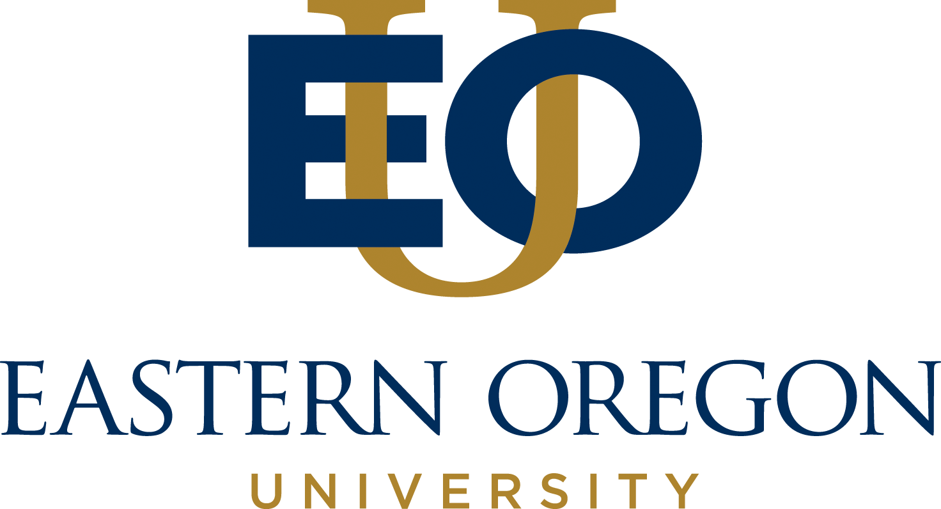
EOU guides student inquiry through integrated, high-quality liberal arts and professional programs that lead to responsible and reflective action in a diverse and interconnected world.
For more information, see eou.edu.

PRESS RELEASE

News contact: Justin Montgomery, Director of Marketing | 541-962-3517 or jmontgomery4@eou.edu

FOR IMMEDIATE RELEASE − October 1, 2026

EOU Sees More Students Finishing Degrees, Plans for More Success

LA GRANDE, Ore. – Eastern Oregon University (EOU) is growing in key parts of its student body. Graduate enrollment measured in the fall term rose about 50% between 2023 and 2025, and early fall numbers show continued growth. On-campus enrollment rose 7.5% over the same period. The number of rural students grew 24% from 2024 to 2025. More students are also earning their degrees. EOU's four-year graduation rate increased 7%.

"Our success is measured by outcomes like this. It is important that we live up to the promise of seeing students graduate," President Kelly A. Ryan said. "We set goals, we did the work, and the numbers show it. More students are finishing at EOU than ever in our records, and we plan to keep going."
EOU was awarded a federal TRIO grant last year. The program now serves 129 students across online, on-campus, and hybrid formats, including first-generation students and those from low-income families. In addition, retention grants helped 23 students reach their final terms last year, more than the University's goal.
Other innovations include EOU's Monty chatbot, which connects with students by text. The chatbot had a 93% opt-in rate and flagged more than 90 students who were at risk of leaving. The Learning Center recorded 2,613 tutoring visits from 524 students. Student engagement rose 18% over 2024, and 76.2% of students who answered a survey said they use the renovated Hoke Student Union more often.
EOU secured three grants to increase postsecondary attainment in rural Oregon:
- $400,000 in federal funding for early college programs
- More than $200,000 from the Oregon Department of Education to help immigrant and refugee students move to EOU
- $1.3 million from the Oregon Health Authority to prepare rural health professionals
EOU also signed the Eastern Alliance, a transfer agreement with Blue Mountain Community College (BMCC). BMCC sent 32 new transfer students to EOU this fall, more than any other school. The university joined Re-UP, a partnership with four other Oregon universities that helps adults with some college credit finish a degree, and EOU launched a new website on Sept. 14.
Student athletes make a vital contribution to enrollment and campus life. EOU teams were #1 in the 2025-2026 Cascade Collegiate Conference (CCC) All-Sports Champion Final Standings. EOU Athletics also ranked 19th in the National Association of Intercollegiate Athletics (NAIA) Learfield Cup, which measures overall athletic program success based on national championship performances. Athletes earned a combined GPA of 3.37 last year, and 48% made the dean's list.
"Nobody handed us these results,” Ryan said. “Our faculty and staff worked hard, academics were prioritized, our students showed up, and EOU is on the right track. We are not done."
Prepare for the world beyond college with Eastern Oregon University’s high-quality liberal arts and professional programs. Classes are available when and where you need them – at our main campus in La Grande, online almost anywhere in the world, or onsite at our centers across the state. Educational, cultural, and economic growth is important to our region, state, and nation. That’s why we are committed to providing a personal, student-centered experience in all that we do. Visit eou.edu for more information.
###

One University Blvd., La Grande, OR 97850 | 541-962-3740 | ua@eou.edu

