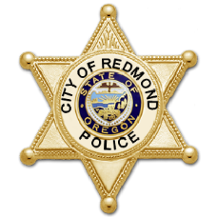
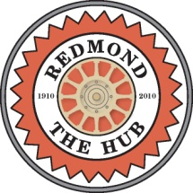
411 SW Ninth Street
Redmond, OR 97756-0100

CITY OF REDMOND

news release

Date: July 13, 2026
Contact: April Huey
April.Huey@redmondoregon.gov

Redmond Police Department to Host National Night Out Community Event in Centennial Park
- Bringing Police and Neighbors Together

REDMOND, OREGON - On Tuesday, August 4, from 6:00 p.m. – 8:00 p.m. the City of Redmond Police Department (RPD) will host a National Night Out community event at Centennial Park. National Night Out is an annual community-building campaign that promotes police-community partnerships and camaraderie to make our neighborhoods safer, more caring places to live. The event is free to attend, including all family-friendly activities, live performance by Precious Byrd, sno-cones, and a barbecue.

“This nationwide event encourages neighbors and law enforcement to come together, build trust, and strengthen the relationships that play a vital role in reducing crime before it starts,” remarks Mayor Ed Fitch. “We invite everyone to join us in celebrating the power of community connection and our shared commitment to a safer, more resilient Redmond.”

Enjoy K-9 demos, Dunk-a-Cop tank, face painting, music, bouncy houses, emergency service vehicles on display and much more. RPD community partners will host information and activity booths and there will even be a donut eating contest.

Centennial Park’s splash pad will remain open till to 8:00 p.m., so kiddos may enjoy running through the water fountains during Redmond’s National Night Out event.

For additional event information please visit www.redmondoregon.gov/nationalnightout. To learn how you can get involved or support National Night Out, contact Captain Jesse Petersen at 541-504-3473 or jesse.petersen@redmondoregon.gov.

###
MEDIA CONTACTS:

Jesse Petersen, Captain City of Redmond Police Department
P: 541.504.3473 E: jesse.petersen@redmondoregon.gov

April Huey, Lieutenant City of Redmond Police Department
P: 541.504.3484 E: April.huey@redmondoregon.gov

