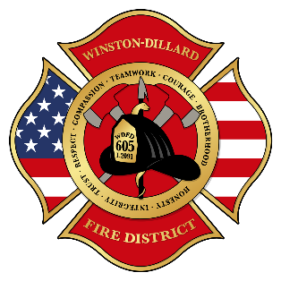
Winston Dillard Fire District No. 5
A Community Organization Since 1952.

MEMORANDUM
To: Winston Dillard Fire District Citizens
From: Fire Chief Rob Bullock
Date: April 21, 2026
Subject: Notice of Civil Service Meeting

The Civil Service Commission of Winston Dillard Fire District No. 5 will hold a meeting on Thursday April 23, 2026, at 10:00 AM. The meeting will be held at 250 SE Main St. Winston, OR 97496. To comply with House Bill 2560, those that wish to participate can attend through videoconferencing or telephonically. If you plan on attending the meeting, please call the business office at 541-673-5503 during normal business hours prior to 10:00 AM on Thursday April 23, 2026, for instructions.

The agenda to include but not limited to:
- Certify Lieutenant List
- Discuss Civil Service Commission Appointments
- Certify Payroll FY2026

The meeting location is accessible to persons with disabilities. A request for an interpreter for the hearing impaired or for other accommodations for persons with disabilities should be made at least 24 hours before the meeting to WDFD at 541-673-5503.
Posted in an exterior window assessable to public view at the following locations until 4/23/2026.
Station 656/250 SE Main St Winston
Winston Post Office/291 SW Main St. Winston
Douglas County Court House/1036 SE Douglas
Station 651/1400 Buckhorn Rd. Roseburg
Station 652/4200 Carnes Rd. Roseburg
Station 653/2830 Melrose Rd. Roseburg
Station 654/6576 Old Hwy 99N. Roseburg
Station 655/6000 Garden Valley Rd. Roseburg

