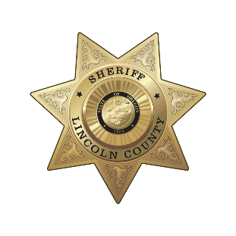
Lincoln County Sheriff’s Office
Sheriff Adam D. Shanks

225 W. Olive Street
Newport, Oregon 97365
(541) 265-4277

MEDIA RELEASE
FOR IMMEDIATE RELEASE

Date: March 12, 2026

Contact: Sheriff Adam Shanks
541-265-6052
lcsheriff@co.lincoln.or.us

2025 ANNUAL REPORT PUBLISHED
3/11/26 – Lincoln County, Oregon
The Lincoln County Sheriff’s Office (LCSO) is pleased to share our 2025 Annual Report. In 2025, Sheriff Shanks motivated the LCSO team to refine our basic and core functions, so our teams will be ready to tackle bigger and better things for our communities. The Sheriff’s Office also created a new strategic plan for 2025 – 2028 to help steer efforts while we continue to address community concerns, rise to meet new challenges, and serve all of our communities.
Although it is hard to capture all accomplishments over the last year, our team has tried to summarize major activities and services completed by your Sheriff’s Office.
The full report can be found at: www.co.lincoln.or.us/Archive.aspx?AMID=52

###

