PRESS RELEASE FOR IMMEDIATE RELEASE

Headline: Volunteers Meet to Prepare Tillamook Forest Center for Spring Re-Opening; 20th Anniversary of Tillamook Forest Center; Unveiling of new Lockers, a gift from State Forests Trust of Oregon
Dateline: Tillamook, February 19th
- Who: Volunteers of all types and ages will convene at the Tillamook Forest Center (TFC), along with staff members from the Center and the Oregon Department of Forestry REI Division, to clean and prepare the TFC for it’s 20th Spring Opening. This winter, new lockers were installed to help upgrade the volunteer experience. The lockers were a gift from the State Forests Trust of Oregon.
- What: The Tillamook Forest Center first opened in April of 2006. Since that time, it has become a highly rated center for outdoor education, forest literacy, fire-prevention awareness, forestry exhibits, and access to the Wilson River for locals, students, and visitors from across the US and foreign countries. The new lockers are designed to upgrade the volunteer experience, providing secure storage for personal items during the volunteers shift.
- When: The event takes place from 9:30 am-12;30 pm on Saturday, February 28th, 2026. The Center will not be open to the public at this time. Only volunteers who register for the event will be admitted.
- Where: at the Tillamook Forest Center, 45500 OR-6, Tillamook, OR 97141
- Why: the center closes every winter, due to prevailing poor weather conditions and low winter-time visitor counts. In late winter, staff and volunteers come together to clean and prepare the Center for reopening. The Center reopens this spring on Wednesday, March 4th, at 9am.
- How: Participants will dust exhibits, wash windows, clean the break room, and perform other tasks needed after the nearly three-month hiatus. A light luncheon will be served, courtesy of The State Forests Trust of Oregon, a non-profit group which supports the staff, events and activities of the REI Division of ODF, which operates the TFC. Volunteers will also get a backstage tour of the center and an update on its 20-year evolution.
To register to participate: Registration by February 25th is required. To register, or for more information, email us at TFC.InterpretationandEducation@odf.oregon.gov or call 503-815-6807.
Quotes
Virginia Ohler, State Forests Trust: On behalf of the many donors who have contributed to this project, the Trust is excited to be able to provide these new lockers for the amazing folks who volunteer at the Tillamook Forest Center. The Tillamook Forest Center provides a world-class visitor experience, thanks to their beautiful exhibits, incredible staff and amazing volunteers. We are proud to support this impactful work, right in our own back yard.
Denise Berkshire, Manager, Tillamook Forest Center: A Huge Thank You to the State Forests Trust! Our volunteers are the heart of the Tillamook Forest Center, and thanks to a wonderful new gift from the Trust, we are able to support them better than ever! We are incredibly thankful for this investment in the people who make our work possible."

“About Us"
The Tillamook Forest Center is the region’s largest forest-based learning center and outdoor classroom — a special place to develop a deeper connection with Oregon’s state forests through hands on exploration of the past, present, and future.
Through innovative programs and hands-on exhibits in the 13,500 square-foot Center, visitors can gain a greater understanding about what a forest is, how forest ecosystems work, how modern forests are managed, and forest history.

The Center also showcases the historic Tillamook Burn, the public spirit behind the monumental reforestation effort that left a permanent mark on Oregon history, and how it shaped sustainable forest management today.

https://www.tillamookforestcenter.org/

The State Forests Trust of Oregon is an independent, 501-c-3 charitable non-profit organization dedicated to helping Oregonians and visitors enjoy and appreciate Oregon state forests. The Trust helps fund improved access for anglers, off-road vehicle enthusiasts, hikers, and other people as they experience the wonder of Oregon’s beautiful natural heritage.
In addition, the State Forests Trust of Oregon (SFT) supports programs to deepen Oregonian’s understanding of the many benefits of state forests.
Founded in 1999, SFT (formerly “Tillamook Forest Heritage Trust”) brought the community together to build the Tillamook Forest Center, where visitors learn about the Tillamook Forest’s first inhabitants, the disastrous wildfires of early last century, as well as the work of the Oregon Department of Forestry to manage state forests. The Trust helps expand trail systems, study visitor use of recreation areas and helps restore areas impacted by the 2020 Labor Day fires.
https://www.stateforeststrust.org/

Media Contact:
Denise Berkshire, Manager, Tillamook Forest Center Denise.BERKSHIRE@odf.oregon.gov
Virginia Ohler, Exec. Director, State Forests Trust: 503-310-9585 virginia.ohler@stateforeststrust.org
Jospeh Offer, REI Program Manager, ODF: joseph.h.offer@odf.oregon.gov
Link to Media Kit:
https://www.tillamookforestcenter.org/press/mediakit
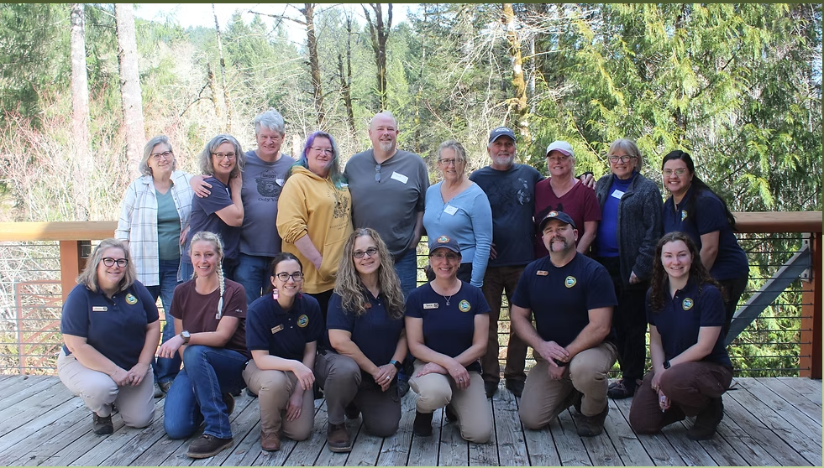
TFC Staff and volunteers pause for a photo
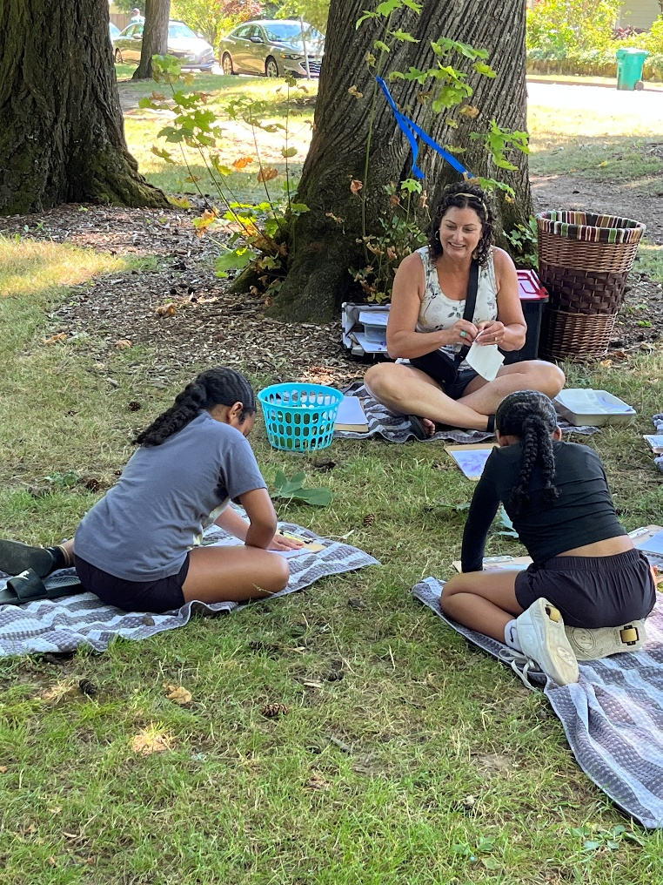
Students visiting the TFC to learn about trees and the forest.

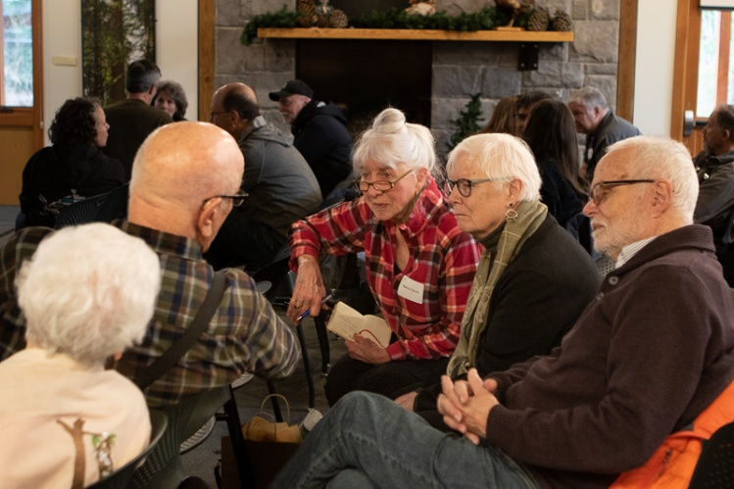
Visitors at TFC enjoying a special program.

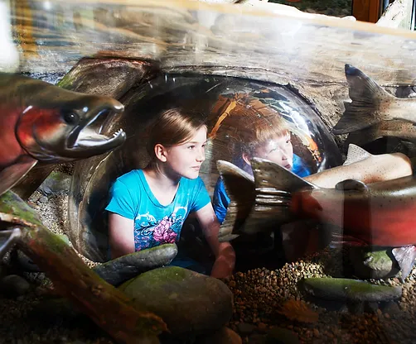
Children enjoying an “under the stream” exhibit at TFC.

Link to Photo Gallery:
https://www.tillamookforestcenter.org/press/photogallery?pgid=lxr9nnde1-8126afae-55dd-4fe7-a4a5-5720e1748316

###END###

