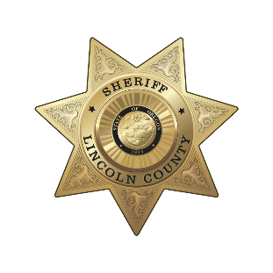
Lincoln County Sheriff’s Office
Sheriff Adam D. Shanks

225 W. Olive Street
Newport, Oregon 97365
(541) 265-4277

MEDIA RELEASE
FOR IMMEDIATE RELEASE

Date: February 25, 2026

Contact: Sheriff Adam Shanks
541-265-0652
lcsheriff@co.lincoln.or.us

QUARTERLY COFFEE WITH A DEPUTY – NEWPORT
The next Quarterly Coffee with a Deputy event with the Lincoln County Sheriff’s Office is just around the corner. Join us on Tuesday, March 10, 2026, from 9:30am – 11am for a cup of coffee and a conversation at Ultralife Cafe (located at 715 NW Beach Drive Newport, OR 97365).
More about these quarterly events:
Every three months our office partners with a local coffee shop in Lincoln County to provide a time, space, and coffee for community members to meet our team and share what’s on their minds. Coffee with a cop events are a friendly and relaxed way for our communities to connect with the deputies that serve them.
These events offer a unique opportunity for community members to directly engage with law enforcement, ask questions, voice concerns, and build positive relationships. Whether you're a regular coffee drinker or simply curious about the work of law enforcement, this is a chance to connect with our team on a personal level, learn about each other’s experiences, and share local feedback.
###

