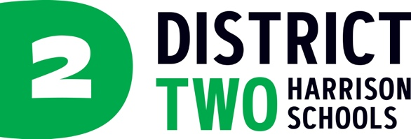

NEWS RELEASE

August 21, 2025

Media contact:
Christine O’Brien, Chief Communications Officer
Cell: (719) 660-2033
cobrien@hsd2.org
Harrison School District 2

D2 Awarded $1,440,000 Comprehensive Literacy State Development Grant

COLORADO SPRINGS – Harrison School District 2 receives award funds in the sum of $1,440,000 over the course of four years spanning from July 1, 2025, through June 30, 2029, through the Comprehensive Literacy State Development Grant, a competitive federal grant from the U.S. Department of Education.
Half of the funds will be allocated to programming and support for grades kindergarten through fifth grade and half of the funds will be allocated for sixth through twelfth grade. Support and programming will include increasing professional learning opportunities for teachers and instructional leaders relating to high-impact and evidence-based literacy methods, family and community engagement in the literacy development, and providing literacy supports directly to D2 students. The grant is designed to improve literacy outcomes with a specific emphasis on children living in poverty, children with disabilities, and English learners.
Comprehensive Literacy State Development Grant
The Comprehensive Literacy State Development (CLSD) Grant Program is a competitive federal grant from the U.S. Department of Education designed to improve literacy outcomes from birth through grade 12. The program emphasizes the use of evidence-based practices to support the development of literacy skills, including emergent literacy, with a special emphasis on children living in poverty, English learners, and children with disabilities. The grant supports state-level activities over a five-year period and funds four-year local literacy projects through a competitive process.

--
For more information, please contact Christine O'Brien at the numbers listed above

