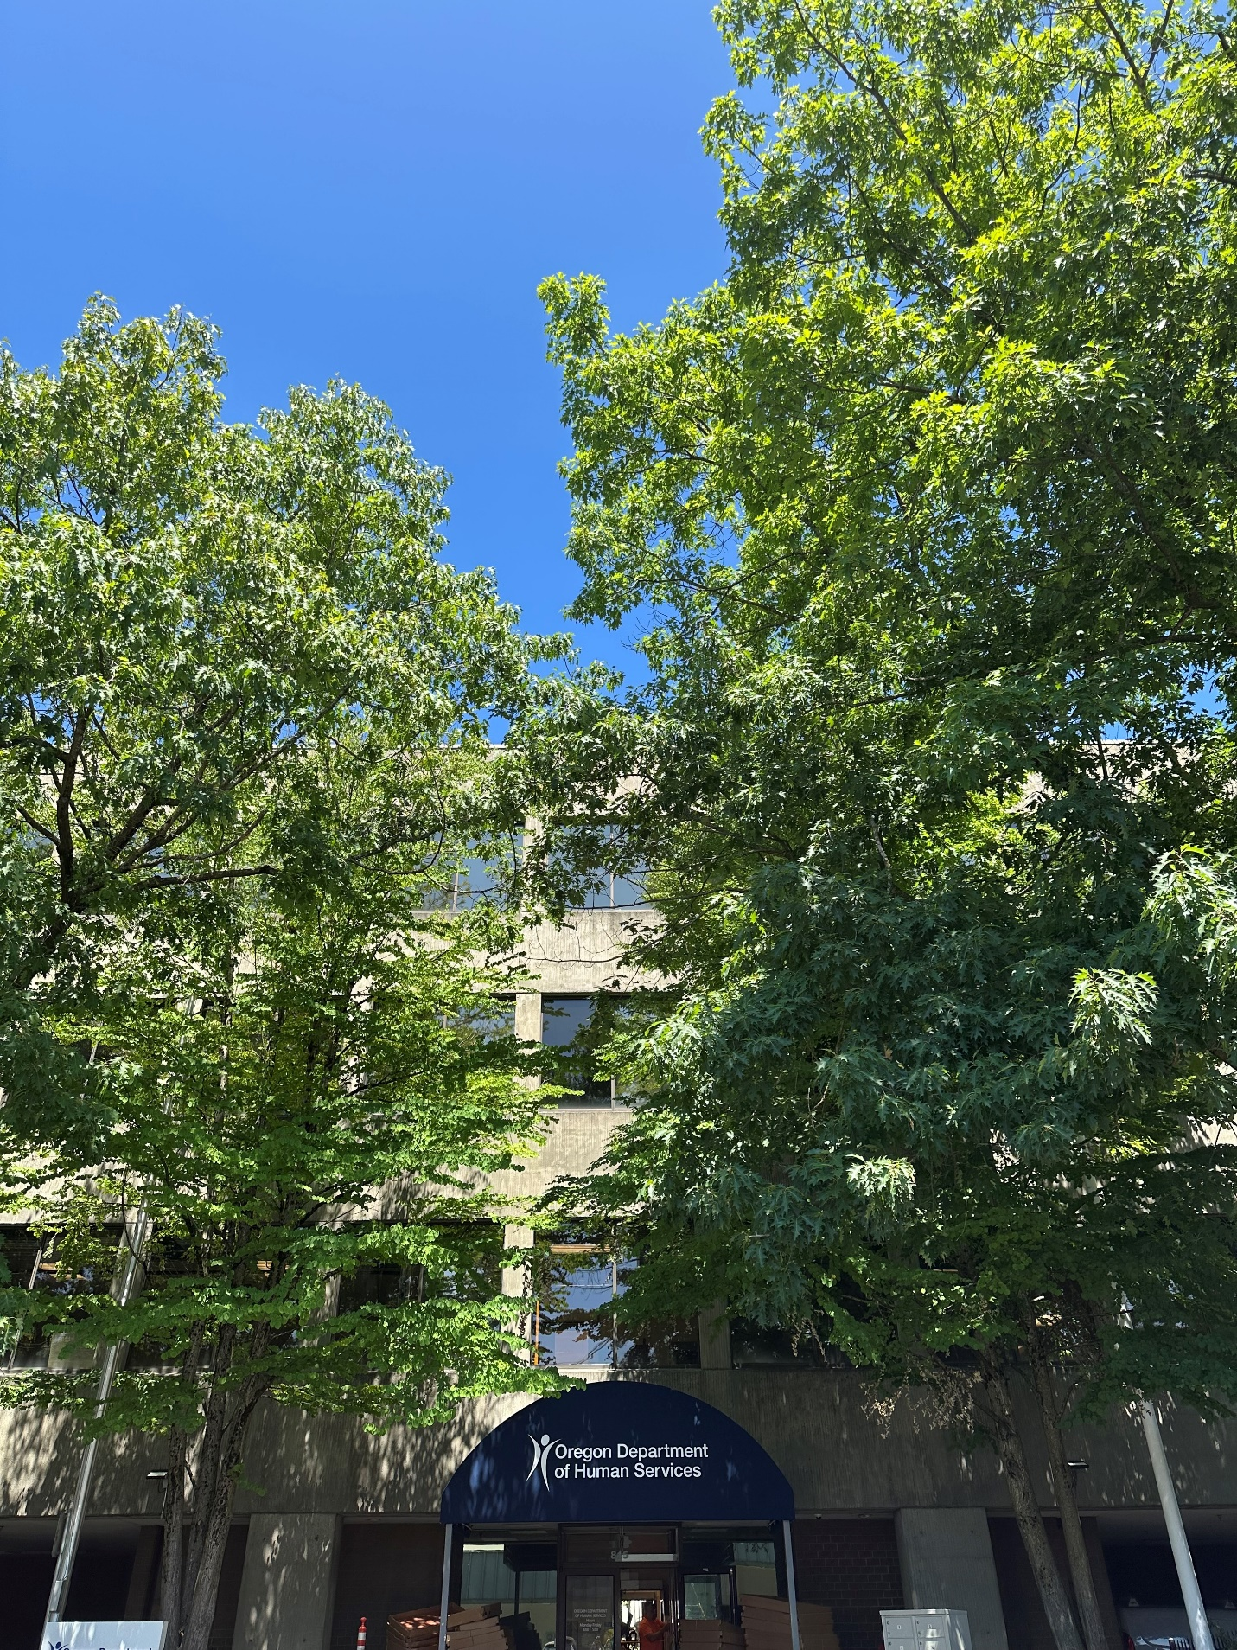
Figure 1 815 Davis St., Portland

