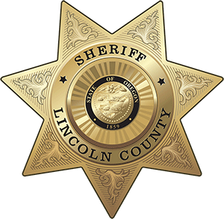OFFICE OF THE SHERIFF

# Sheriff Curtis L. Landers

225 W. Olive Street

Newport, Oregon 97365

(541) 265-4277

Fax (541) 265-4926

## 

## **MEDIA RELEASE**

**FOR IMMEDIATE RELEASE**

Date: December 19, 2024

Contact: Sheriff Curtis Landers

541-265-0652

[lcsheriff@co.lincoln.or.us](mailto:lcsheriff@co.lincoln.or.us)

**LINCOLN COUNTY SHERIFF’S OFFICE RESPONSE TO CONCERNING LETTERS CIRCULATING**

The Lincoln County Sheriff’s Office recently learned about a letter being circulated throughout Lincoln County which encourages community members to track and report information regarding people of color, specifically community members that are believed to be undocumented. We want to be unequivocal in our stance: this type of behavior is harmful, divisive, and inconsistent with the values we uphold as public servants and community members. Targeting individuals in this manner erodes trust and undermines the sense of safety and inclusion that we strive to maintain in Lincoln County.

One of the things we tell each person when they join our team is to “do the right thing”. We are encouraging our community members to do the right thing and use compassion as we encounter these types of messages. We strongly advise against engaging in activities such as those outlined in this letter, including collecting or sharing information about individuals based on their demographic or perceived immigration status.

In addition to valuing diversity and equity, the Lincoln County Sheriff’s Office is committed to upholding Oregon law with regard to immigration enforcement. Oregon law generally prohibits the inquiry or collection of an individual’s immigration or citizenship status, or country of birth, with few specific exceptions as outlined in Oregon Revised Statute 181A.823. Consistent with this, the Sheriff’s Office does not inquire about, document, or share such information with Immigration and Customs Enforcement (ICE). These provisions are embedded in our policy manual and are essential to ensuring that our practices respect the rights and dignity of all individuals.

The mission of the Lincoln County Sheriff’s Office is to enhance public safety, reduce the fear and impact of crime, and improve the quality of life for all. We are committed to continuous learning and growth to better serve every member of our community. Diversity strengthens our communities, and we take pride in growing and thriving alongside the people we serve.

**###**