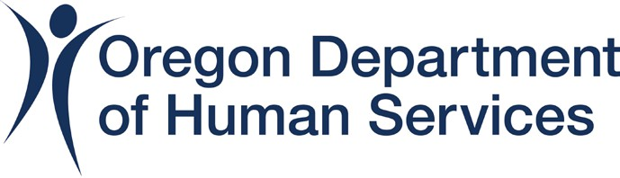


News Release
Date: July 5, 2024
Contact:
ODHS, Diane Navarrete, diane.navarrete2@odhs.oregon.gov
211info, Cara Kangas, cara.kangas@211info.org
Shelters now open to help people stay cool during heat wave, organizations encouraged to report cooling options to 211info

(Salem) – Cooling centers are opening across Oregon to help people beat the heat during excessively high temperatures this week. The Oregon Department of Human Services (ODHS) is working with 211info to get information out and ensure the safety and well-being of everyone in Oregon, especially those most vulnerable to heat-related illnesses.
"Our top priority is health and safety during this heat wave," said Ed Flick, Director of the ODHS Office of Resilience and Emergency Management (OREM). "We urge everyone to look out for one another and use the resources available. If you or someone you know is not safe in their home due to heat, call 211 or visit 211info.org to locate cooling centers and other hot weather resources in your area. If you are concerned someone is having a medical emergency, call 911."
ODHS is working closely with local partners to ensure that the cooling centers around the state are staffed and equipped. The agency is prioritizing the distribution of resources like water bottles, climate control systems like air conditioners and more to these locations to address immediate health concerns and prevent heat-related illnesses. As of July 4, ODHS has delivered 14 pallets, or 1,176 cases, of water bottles to partners serving vulnerable populations, like churches, shelters and community-based organizations.
In addition, ODHS and 211info have partnered with some transportation services to offer rides to cooling centers. Call 211 to check what transportation options are available near you.
“211info is available 24/7, and our team is ready to answer questions about heat-related resources, cooling centers, and transportation options," said Kerry Hoeschen, 211info’s statewide Emergency Management Director. "We’ve also increased our staffing levels to ensure timely responses to calls."
ODHS is also working with Oregon Health Authority (OHA) and community-based organizations to distribute air conditioning units to help people in need stay cool. As of July 4, ODHS has distributed 616 units to community-based organizations. This initiative is separate from the program OHA reported on earlier this week, as ODHS delivers units to people and communities who may not be Oregon Health Plan recipients. The agencies anticipate delivery of more than 1,500 units over the course of the heat event.
To locate cooling centers in your area:
- Call 211 or 1-866-698-6155
  - Help is available 24 hours per day / 7 days per week
- Visit 211info.org
  - Click on the globe on the top right to select your preferred language.
  - Click the house icon for housing and shelter, then click “severe weather shelter” and “extreme heat cooling centers,” or visit 211info.org/summer-and-heat-related-resources
  - Enter your zip code to search for cooling centers in your area.
If your organization has cooling options, like clean water, splash pads, or shelter available:
- Call 211info’s Resource Team at 503-416-2698;
- Or email support@211info.org
The Oregon Department of Human Services works with partners across the state to help people in Oregon during emergencies. When an emergency happens, our role is to help people find food, shelter and meet other basic needs. The Office of Resilience and Emergency Management (OREM) coordinates this work at ODHS.
211info helps Oregon and SW Washington communities identify, navigate, and connect with local health and social services, 24 hours a day, 365 days a year. Contacting 211 connects to live agents who offer confidential support and live translation services in over 240 languages.
###

