ARTIFICIAL INTELLIGENCE
OREGONIANS BY THE NUMBERS AND IN THEIR OWN WORDS
KEY FINDINGS
INTRODUCTION

From December 19th, 2023 - January 7th, 2024, the Oregon Values and Beliefs Center conducted a statewide survey of Oregonians’ values and beliefs about artificial intelligence. This survey was designed as a crucial follow-up to our study from August 4-11, 2023, on the same topic of artificial intelligence (AI). This memorandum summarizes key findings from the two studies and is meant to inform further research to learn more about Oregonians’ attitudes and behavior related to AI.

The question numbers in this document correspond with the accompanying annotated questionnaire and tabs. Due to rounding, the percentages reported below may not add up to 100% or compare exactly to the percentages for the same question in the annotated questionnaire or tabs.

Included below for selected questions are noteworthy subgroup variations for age, gender, area of the state, BIPOC/white, etc. The accompanying set of tabs notes subgroup variations for all the questions.

OVBC surveys currently use aggregated data to analyze the opinions of BIPOC residents in comparison to the opinions of residents who identify as white and not another race. BIPOC residents are not a monolith; the grouping represents a wide diversity of races and ethnicities. The findings included in this memo should not be construed such that all people of color are believed to share the same opinions. Disaggregated race data will be provided when sample sizes permit reliability.

For survey full question wording, all statistically significant subgroup findings, and respondent quotes, readers are encouraged to refer to the accompanying documents: (1) annotated questionnaire, (2) crosstabulations, and (3) verbatim written responses spreadsheet (upon request).

Oregon Values and Beliefs Center (OVBC): This research was completed as a community service by the Oregon Values and Beliefs Center. OVBC is an independent and non-partisan organization and an Oregon charitable nonprofit corporation. Representative OVBC projects include opinion research about race-based crimes for the Asian Health and Service Center, as well as research about early childhood education and the cost of childcare for the Children’s Institute.

ARTIFICIAL INTELLIGENCE: FREE ASSOCIATION - SEMANTICS AND IMAGERY

- According to our survey from August 2023, many Oregonians express general wariness concerning artificial intelligence (AI), citing their fears of related job loss, information inequality, lack of regulations, and the rapid development of artificial intelligence. While some Oregonians note beneficial usage of AI, many feel ill-equipped to understand and reap the benefits of AI development (Q9 July-Aug 2023):

“I feel like I don't have a great understanding of how AI operates and what the intention is behind it. It is concerning to me, when we compare the impact of the internet and the evolution of social media platforms. There are two sides to one coin, there will be positives and there will be uncontrollable and consequential negatives.”
Non-binary or gender non-conforming, age 30-44, Multnomah County, White

“It will have as much influence as the printing press did. Currently, almost everyone is able to read to some extent, in the next few generations, the same will be true for the use of AI in everyday life.”
Man, age 30-44, Multnomah County, White

“I am optimistic about artificial intelligence. I believe that AI technology can have a positive impact on society, improve medical care, increase production efficiency, and solve environmental problems. I look forward to creating more opportunities and convenience for human beings.”
Man, age 18-29, Benton County, Black or African American

- Follow up research in December reflects similar concerns over the developmental rapidity of AI and lack of good regulatory means to control AI. Overall, Oregonians display a general wariness regarding AI, paired with the understanding that AI could, if controlled correctly, benefit society in novel ways (Q29 Nov-Dec 2023).

“We must regulate these emerging technologies so that the outcome will be one of public good, as opposed to how the internet was treated when emerging, which led to what it is today.”
Man, age 30-44, Multnomah County, White

“AI absolutely needs more regulation and need to be open about where they get the information/training data for their models. We also need to know how much copyrighted material they have been using.”
Woman, Non-binary or gender non-conforming, age 18-29, Klamath County, Asian, Native American, American Indian, or Alaska Native, White

“It scares me. I am afraid it will lead to major changes in our society, education, and work culture that we aren’t prepared for, with disastrous consequences.”
Woman, age 45-54, Douglas County, White

EXPERIENCE WITH ARTIFICIAL INTELLIGENCE

Source: OVBC survey conducted August 4-11, 2023, among Oregon adults
(representative sample, N = 2,710) (Q20 July-Aug 2023)

- Most Oregonians report having used GPS and mapping technologies (73%), virtual assistants like Siri and Alexa (65%), online algorithms like autofill and social media tracking tools (61%), spam filters (59%), and e-commerce which includes personalized shopping and fraud prevention tools (50%) (Q20 July-Aug 2023).
- On the other hand, Oregonians express low levels of exposure to robotics (20%) and autonomous cars (9%).
  - Around 7% of Oregonians express a lack of exposure to all forms of AI asked about in the question (Q20 July-Aug 2023).
FUTURE PREDICTIONS FOR AI

Benefits and Drawbacks of AI

- Respondents were asked an open-ended question as to what areas of society they think would benefit the most from AI (Q23, July-Aug 2023). Some of the themes mentioned with the greatest frequency are medical, research, jobs, science, education, security, data, diagnostics, manufacturing, crime, space, and law.
In what area of society do you think AI could be most beneficial?
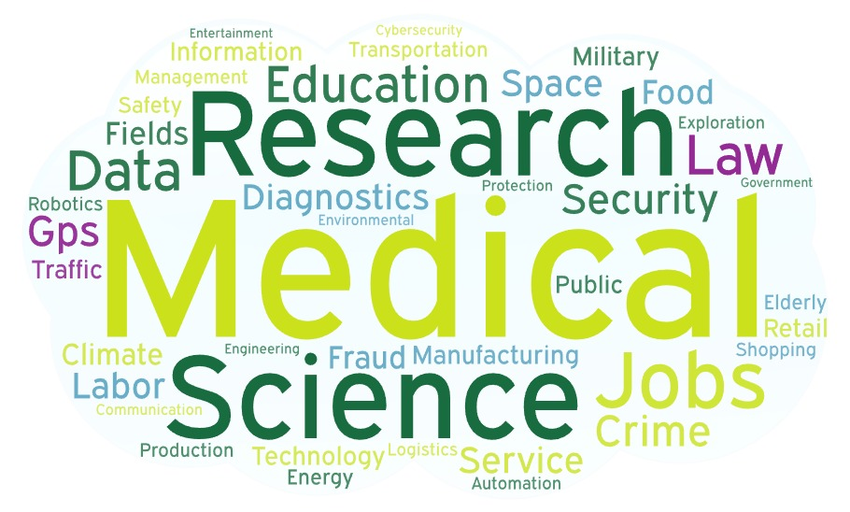
Source: OVBC survey conducted August 4-11, 2023, among Oregon adults
(representative sample, N = 2,710) (Q23 July-Aug 2023)

- Respondents were also asked an open-ended question as to what areas of society they think would benefit the least from AI (Q24, July-Aug 2023). The following themes were most frequently mentioned: job, politics, art, education, military, medical, media, creative, service, work, security, and writing.
In what area of society do you think AI may be least beneficial?
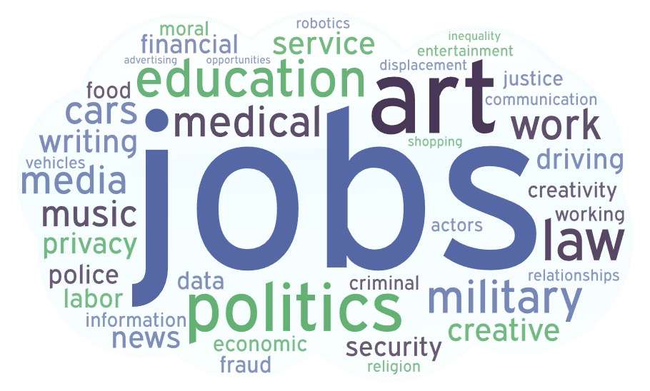
Source: OVBC survey conducted August 4-11, 2023, among Oregon adults
(representative sample, N = 2,710) (Q24 July-Aug 2023)
AI DEVELOPMENT

Qualifications for AI Regulation

- Oregonians believe individuals and organizations making AI-related decisions should be equipped with expertise in AI and ethics. Additionally, Oregonians believe transparency, checks and balances, and the prioritization of public welfare are essential qualities for those making AI-related decisions (Q31 July-Aug 2023):

“Common sense approach, logical thinking, long-range projection and planning, the overall desire to make humanity better, not just more convenient or faster.”
Man, age 65-74, Josephine County, White

“I don’t think one solid organization should have the ability to make this choice. I think it should be a mass group decision-making process after more research is done.”
Woman, age 18-29, Washington County, Hispanic/Latino/a/x

“They should be divorced from the profit motive and interested in protecting the general welfare.”
Man, age 30-44, Clackamas County, White

“Empathy at the core, diverse backgrounds in philosophy, metaphysics, technology, sociology etc.”
Woman, age 30-44, Lane County, Asian

- Responses from December 2023 reflect a similar emphasis on technological expertise, transparency, and checks and balances (Q29 Nov-Dec 2023):

“AI must be regulated by experts in positions that will be transparent and monitored.”
Man, age 65-74, Multnomah County, White

“Unbiased people with expertise should be called in to educate our lawmakers. This is critical.”
Woman, age 30-44, Benton County, White

“I think the government should control how people are advancing AI, AI is very capable and should be watched.”
Woman, age 18-29, Washington County, Native American, Hispanic or Latino/a/x
Trustworthy AI Decision-Makers

Source: OVBC survey conducted August 4-11, 2023, among Oregon adults
(representative sample, N = 2,710) (Q30 July-Aug 2023)

- According to the August 2023 survey, Oregonians view the scientific community as the most trustworthy group when it comes to making AI-related decisions, but even the scientific community is trusted by fewer than half (47%). Oregonians also see ethics experts (40%) and leading teaching universities (37%) as more trustworthy than technology companies (23%), ordinary people (22%), international bodies like the United Nations (20%), and governments (17%). Oregonians express the least amount of trust for religious and spiritual leaders when it comes to making AI-related decisions (8%) (Q30 July-Aug 2023).

- According to the December 2023 survey, however, Oregonians are almost evenly split in thinking either independent experts (51%) or the public and their elected officials (49%) should be in charge of regulating AI. Notably, only 18% of Oregonians feel strongly in support of either group, with 65% of Oregonians only leaning one way or the other (Q26 Nov-Dec 2023).
Complex policy questions, such as how to regulate emerging technologies like artificial intelligence…
Source: OVBC survey conducted December 19th, 2023 - January 7th, 2024, among Oregon adults (representative sample, N = 1,807) (Q26 Nov-Dec 2023)
- An interesting perspective emerges from the findings of Q30 July-Aug 2023 and Q26 Nov-Dec 2023. In Q30, which surveys Oregonians about trustworthy entities for AI-related decision-making, only 17% indicate trust in “governments,” while 22% include “ordinary people.” Conversely, the entities considered most trustworthy include the “scientific community” (47%), “ethics experts” (40%), and “leading teaching universities” (37%). These results suggest a higher level of confidence among Oregonians in the expertise of private entities compared to ordinary citizens or elected officials. However, Q26 from Nov-Dec 2023 shows that Oregonians are almost evenly split in thinking either independent experts or elected officials should make policy decisions regulating emerging technology like AI.

State government…
Source: OVBC survey conducted December 19th, 2023 - January 7th, 2024, among Oregon adults (representative sample, N = 1,807) (Q28 Nov-Dec 2023)

- Oregonians generally do not think the state government has the appropriate expertise to regulate artificial intelligence: 66% of Oregonians believe state government lacks necessary expertise to regulate artificial intelligence (Q28 Nov-Dec 2023).

Recommendations for Government About AI

Source: OVBC survey conducted August 4-11, 2023, among Oregon adults
(representative sample, N = 2,710) (Q29 July-Aug 2023)

- As for recommendations for the state government regarding AI, Oregonians heavily emphasize passing regulations at the state level to ensure alignment between AI development and public interest (57%) (Q29 July-Aug 2023).
  - Oregonians show a lack of support for a ban on AI usage by all state government officials and offices (20%).

Government Oversight and Self-Regulation
The corporations developing new technology like AI…
Source: OVBC survey conducted December 19th, 2023 - January 7th, 2024, among Oregon adults (representative sample, N = 1,807) (Q27 Nov-Dec 2023)

- 63% of Oregonians show support for the idea of the government regulating AI over corporate self-regulation (Q27 Nov-Dec 2023).
  - 15% of Oregonians feel strongly that AI developers should self-regulate, whereas 28% of Oregonians strongly believe that the government should regulate AI.
Key Takeaways: Government Regulation of AI

- A synthesis of data from Q29 July-Aug 2023 and Q27-Q28 Nov-Dec 2023 highlights several key points about how Oregonians feel regarding AI regulation:
  - (1) 64% of Oregonians advocate for government regulation of AI over technology companies self-regulating (Q27 Nov-Dec 2023).
  - (2) 57% of Oregonians stress the importance of enacting regulations at the state level to guide AI research towards the public interest (Q29 July-Aug 2023).
  - (3) Despite this, 66% of Oregonians express doubt that the state government possesses the requisite expertise to effectively regulate AI (Q28 Nov-Dec 2023).

NEEDED AI INITIATIVES

Source: OVBC survey conducted August 4-11, 2023, among Oregon adults
(representative sample, N = 2,710) (Q32-39 July-Aug 2023)

- When considering measures in response to AI development, seven out of ten Oregonians support incentives for advancements in technology that allow low- and middle-income residents more affordable access to necessities, like food, housing, and utilities (73%) (Q38 July-Aug 2023).
- Oregonians also generally support international cooperation with allies to control access to AI technology, with an aim to stop adversaries from utilizing AI for weaponry and cyberwarfare (69%) (Q39 July-Aug 2023).
- Most Oregonians also indicate that unemployment benefits are necessary for those who lose their jobs due to AI advancement (73%) (Q34 July-Aug 2023).
- On the other hand, Oregonians show the least support for universal basic income and guaranteed jobs (55% for universal basic income and 52% for guaranteed jobs) (Q35 and Q36, July Aug 2023).
SUMMATION QUOTES

Amaury Vogel, Executive Director:

- “While some Oregonians note potential benefits of AI, many of us feel like we’re not quite up to speed on how to really tap into its potential.”
- “Oregonians are hopeful about AI’s potential to advance research and medicine, but they’re worried about negative impacts on education, jobs, politics, and art. They’re concerned enough about the impact on jobs, they want to make sure people who lose their jobs due to advances in AI receive unemployment benefits.”
- “When discussing necessary measures in response to AI development, seven out of ten Oregonians support incentivizing technology that gives low- and middle-income residents more affordable access to necessities, like food, housing, and utilities. Oregonians also generally support international cooperation with allies to try to prevent AI being used for weaponry and cyberwarfare.”
- “When it comes to making decisions about artificial intelligence, the scientific community is seen as the most trustworthy, but even ordinary people are seen as more trustworthy than the government.”

Research Methodology: The online survey consisted of 1,807 Oregon residents ages 18+ and took approximately 10 minutes to complete. This is a sufficient sample size to assess Oregonians’ opinions generally and to review findings by multiple subgroups.
Respondents were contacted by using professionally maintained online panels. In gathering responses, a variety of quality control measures were employed, including questionnaire pre-testing, validation, and real time monitoring of responses. To ensure a representative sample, demographic quotas were set, and data weighted by area of the state, gender, age, race/ethnicity, and education.
Statement of Limitations: Any sampling of opinions or attitudes is subject to a margin of error. The margin of error is a standard statistical calculation that represents differences between the sample and total population at a confidence interval, or probability, calculated to be 95%. This means that there is a 95% probability that the sample taken for this study would fall within the stated margin of error if compared with the results achieved from surveying the entire population. This survey’s margin of error for the full sample is ±2.30%.

