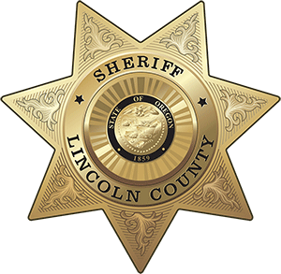
OFFICE OF THE SHERIFF

Sheriff Curtis L. Landers
225 W. Olive Street
Newport, Oregon 97365
(541) 265-4277
Fax (541) 265-4926

MEDIA RELEASE
FOR IMMEDIATE RELEASE

Date: March 15, 2024

Contact: Sheriff Curtis Landers
541-265-0652
lcsheriff@co.lincoln.or.us

2023 ANNUAL REPORT PUBLISHED
The Lincoln County Sheriff’s Office is pleased to share the 2023 Annual Report with our communities. In 2023, our team continued to rise to meet challenges while striving to genuinely connect our community. The Lincoln County Sheriff’s Office prioritized continued training and team development, helping to ensure our members had access to the tools they need to successfully serve all our community members. New partnerships and a new patrol program also emerged in 2023. Many of our team members had their hard work was recognized by outside agencies through various awards.
Although it is hard to capture all accomplishments over the last year, our team has tried to summarize major activities and services completed by your Sheriff’s Office. A sneak peak of the report is listed below and the full report can be found at www.co.lincoln.or.us/ArchiveCenter/ViewFile/Item/266.
Main topics in the report:
- Sheriff’s Message
  - Quick summary of 2023
- Administration
  - Focused events and efforts on recruitment and hiring
  - Increased community outreach by hosting and participating in more community-based events
  - Continued to focus on and improve team wellness
- Emergency Management
  - Created wildfire PSAs in English and Spanish
  - Participated in continued training and exercises
  - Received two million dollar funding for public safety radio upgrades
- Patrol
  - New team members and promotions
  - Met all requirements to become Re-Accredited
  - Established an Electronic Storage Detection Canine Program
- Support Services
  - Attended and hosted training
  - Completed evidence inventory in partnership with Lincoln City Police Department
  - Concentrated effort to offer more concealed handgun license appointments to meet local demand
- Corrections
  - Jail consultation completed and recommendations considered
  - Multiple Adults in Custody earned their GEDs through jail programming
  - Provided meals to Lincoln County Winter Shelters
- Animal Shelter
  - Creative solutions used to continue to meet needs
  - New location announced
  - Increase in stray dogs and decrease in owner’s reclaiming their dogs
  - Partnership with Lincoln County Food Share’s Pet Food Bank to help address local food needs
- Awards
  - Multiple awards received throughout the Sheriff’s Office

###

