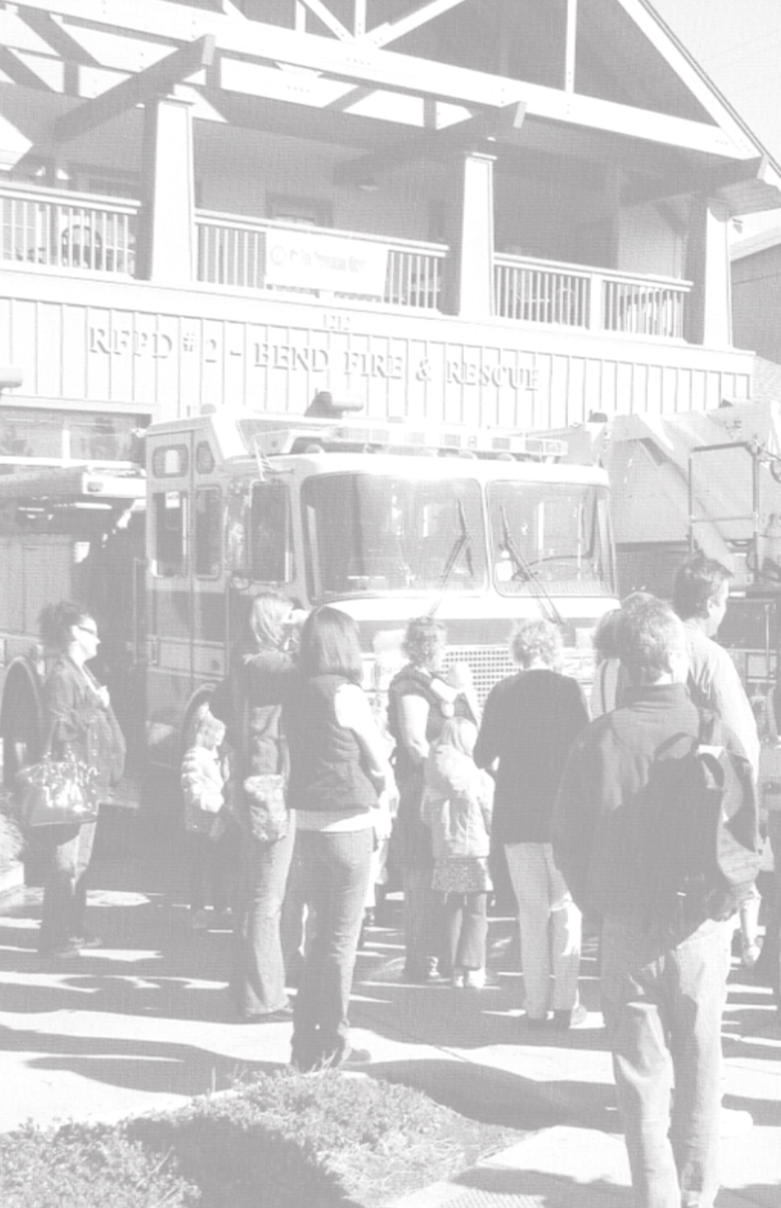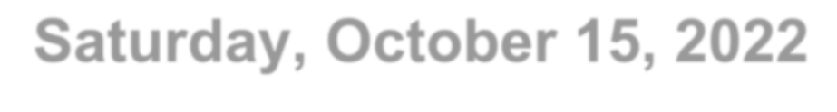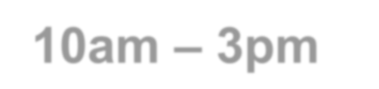

Bend Fire Station North 63377 Jamison Street Bend, Oregon
Saturday, October 14, 2023 10am – 2pm
Join us in celebrating National Fire Prevention Week!
*Meet your firefighters and emergency responders
*Climb aboard a fire engine
*Meet Bend PD & Deschutes County Sheriff’s Office
*Learn about wildfire and home safety
*Emergency Preparedness from the American Red Cross
*Safe Cooking Demo
*An up-close view of AirLink's Helicopter
*Kids Bouncy House & Face Painting
*Learn about local Youth Programs
*Plus, Eberhards Ice Cream for everyone!

For more information call (541) 322-6300 or visit us at www.bendoregon.gov/fire

