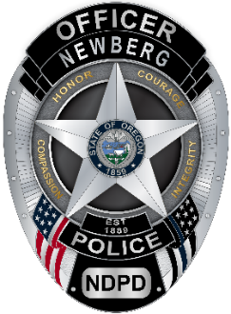
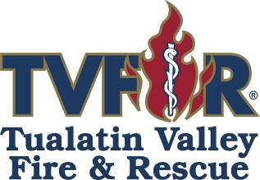

PRESS RELEASE

April 11, 2022

Just after 2:30 a.m. on Sunday, April 10, the Newberg-Dundee Police Department and Tualatin Valley Fire & Rescue responded to the DCI International building at 305 N. Springbrook Road in Newberg, following a call to 911 dispatch reporting a commercial building on fire. While responding to the scene, smoke could be seen coming from the building that was closed for business at the time.
First-incoming crews from TVF&R found the single-story structure fully engulfed in flames upon their arrival. Firefighters began aggressive fire attack measures to keep the flames contained to the 33,000-square-foot structure, preventing any spread to other nearby facilities.
Due to the significance of the fire and its rapid spread throughout the large commercial building, the incident was upgraded to a second alarm, adding more resources from TVF&R and several neighboring mutual-aid fire departments. TVF&R was assisted on scene by McMinnville Fire Department, Dundee Fire Department, Yamhill Fire Protection District, and Dayton Fire District as well as Newberg-Dundee Police Department, Yamhill County Sheriff’s Office, Newberg Public Works, Portland General Electric, NW Natural, and Oregon Department of Transportation.
It took firefighters approximately two hours to deem the fire under control. Crews continued to extinguish hot spots throughout the early morning. The commercial building is a total loss. Initial estimates put the damage in the $5-7 million range. The cause of what started the fire is unknown at this time.
TVF&R fire investigators are working closely with police investigators to determine a cause.
Due to the extreme hazards still present at the fire scene, it has not been possible to search the interior of the building until excavation equipment can be brought in to move large sections of the structure that collapsed.
According to investigators, just prior to discovering the fire, the 911 center received a suspicious call for medical aid at the nearby Fred Meyer store. Emergency personnel did not locate the caller at the location they claimed to be and instead observed the smoke coming from the nearby DCI building. The two incidents are believed to be related, and the fire scene is being investigated as a possible arson.
Additional information will be released as it becomes available.

Sgt. Brian Hagen
Public Information Officer
Newberg-Dundee Police Department
503-538-8321

Stefan Myers
Public Information Officer
Tualatin Valley Fire & Rescue
503-259-1203

