PRESS RELEASE
DEATH INVESTIGATION A20-489
FEBRUARY 15, 2022

In February 2020, human skeletal remains were found by a longshoreman at the Weyerhaeuser dock in Longview, Washington. Detectives with the Cowlitz County Sheriff’s Office and members of the Cowlitz County Coroner’s Office searched the area and found a nearly complete skeleton buried in thick blackberry bushes. The skeleton was collected and the scene was processed. The skeletal remains were sent to the King County Medical Examiner’s Office, where a Forensic Odontologist made a dental record for comparison with the National Missing and Unidentified Persons System (NamUs). Anthropological analysis suggested that the skeletal remains belonged to an adult Caucasian or Hispanic male.
The case details were entered into and searched through National Crime Information Center. Neither the dental records nor the DNA have been able to yield an identity. In 2021, the Cowlitz County Sheriff’s Office partnered with Othram, Inc. to use advanced DNA testing to establish an identification of, or to find a family member of the identified man.
The Cowlitz County Coroner’s Office enlisted the services of Natalie Murry, a Digital Forensic Artist, to complete a digital rendering of the subject, shown below, based on the physical characteristics of the skull.

Anyone with information about this man or the circumstances of his death is encouraged to contact Det. Sgt. Ryan Cruser with the Cowlitz County Sheriff’s Office at (360) 577-3092.
A DNASolves fund has been established to cover the costs of testing for this case and anyone can contribute here: https://dnasolves.com/articles/cowlitz_county_john_doe/.
The case has been logged in NamUs as UP67764.

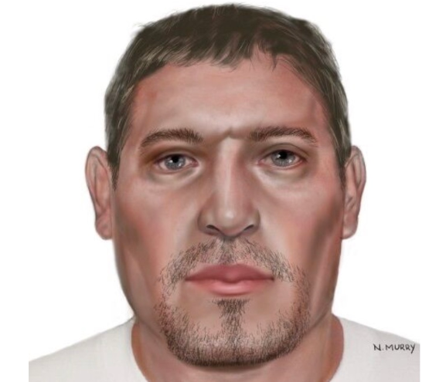

Troy Brightbill
Chief Criminal Deputy
Cowlitz County Sheriff’s Office

