Space Delta 2 change of command
Peterson-Schriever Garrison Public Affairs
By Senior Airman Andrew Bertain
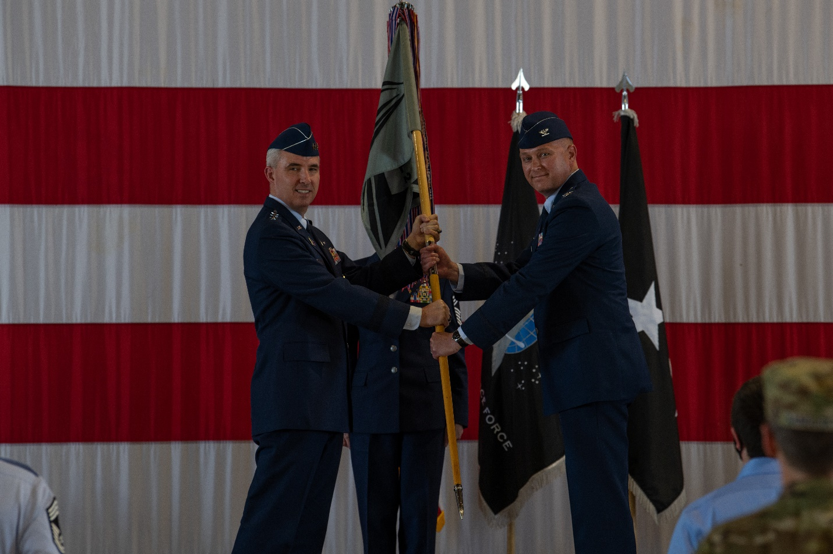
210614-F-GR961-1155
PETERSON AIR FORCE BASE, Colo. – U.S. Space Force Lt. Gen. Stephen Whiting, Space Operations Command commander, left, passes the Space Delta 2 guidon to U.S. Space Force Col. Mark Brock at a change of command ceremony at Peterson Air Force Base, Colorado, June 14, 2021. As the new commander of Space Delta 2 – Space Domain Awareness, Brock became responsible for overseeing DEL 2 operations and executing combat-ready Space Domain Awareness. SDA operations have been the key to deter aggression and, if necessary, defend the U.S. and its allies from attacks in, through and from space. (U.S. Space Force photo by Senior Airman Andrew Bertain)

