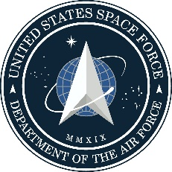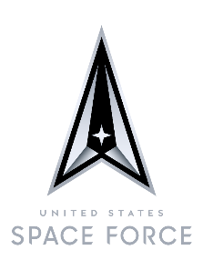

U N I T E D S T A T E S SPACE F O R C E

COLONEL MARC A. BROCK

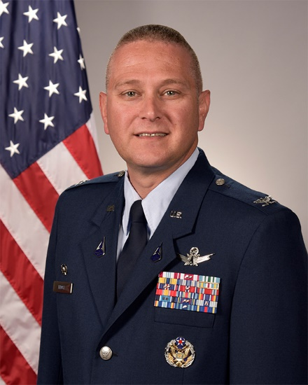
Col Brock is the Commander, Space Delta 2, headquartered at Peterson Air Force Base, Colorado. He commands the Space Domain Awareness Delta spanning the globe with personnel at 10 locations supporting missions in four countries. DEL 2 is responsible for preparing and presenting assigned and attached forces for the purpose of executing combat-ready Space Domain Awareness operations to deter aggression, and, if necessary, fight to protect and defend the U.S. and our allies from attack in, through and from space.

Col Brock was born in Peekskill, NY. He entered the Air Force in May 1998 from Syracuse University with a Reserve Officer Training Corps commission. He has been assigned to numerous operational and staff positions. Prior to his current position, he was the Chief, Programs Division, Headquarters Space Operations Command, Directorate of Plans, Programs and Financial Management, Peterson Air Force Base, Colorado.

EDUCATION:
1998 Bachelor of Science in Aerospace Engineering, Syracuse University
2001 Master of Engineering in Engineering Mechanics, University of Florida
2002 Master of Science in Space Systems, Air Force Institute of Technology
2005 Squadron Officer School in residence
2008 Air Command and Staff College by correspondence
2008 Intermediate Developmental Education, in residence (AFIT credit program)
2013 Air War College, by correspondence
2019 Master of Strategic Studies from the Army War College, in residence (Distinguished Graduate)

ASSIGNMENTS:
- June 1998 - February 1999, Casual Status, 564th Missile Squadron, Malmstrom, MT
- February 1999 - May 1999, Undergraduate Space and Missile Training, and AN/FPS-85 Initial Qualification Training, 392nd Training Squadron, Vandenberg AFB, CA
- May 1999 – July 2002, Operations Crew Commander, Deputy Chief and Chief of Operations Training, 20th Space Surveillance Squadron, Eglin AFB, FL
- July 2002 - March 2004, Graduate Student, Air Force Institute of Technology, Wright-Patterson AFB, OH
- March 2004 - January 2007, Chief, Space Analysis Branch and Deputy Chief Kinetic Effects Division, Air Force Tactical Exploitation of National Capabilities, Schriever AFB, CO
- January 2007 – May 2007, Orbital Analyst, 1st Space Control Squadron, Cheyenne Mountain Air Station, CO
- May 2007 - July 2008, Operations Support Flight Commander, 1st Space Control Squadron, Vandenberg AFB, CA
- July 2008 – January 2010, Chief, Operations Plans Branch, Unified Space Vault, Vandenberg AFB, CA
- January 2010 – February 2011, Executive Officer to Deputy Commander, JFCC SPACE, Vandenberg AFB, CA
- January 2011 – June 2012, Space Force Programmer and Chief Integration Branch, Space and Cyberspace Division, Directorate of Programs, Headquarters U.S. Air Force, Washington, D.C.
- June 2012 - November 2012, Executive Officer to the Assistant Deputy Chief of Staff for Strategic Plans and Programs, Headquarters U.S. Air Force, Washington, D.C.
- November 2012 – May 2013, Engagement and Training Officer, Office of Defense Cooperation, Beirut, Lebanon
- May 2013 – February 2014, Executive Officer to the Executive Director, Headquarters Air Force Space Command, Peterson AFB, CO
- February 2014 – June 2015, Director Of Operations, 21st Operations Support Squadron, Peterson AFB, CO
- June 2015 – June 2016, Commander, 12th Space Warning Squadron, Thule AB, Greenland
- June 2016 – December 2017, Deputy Commander, 21st Operations Group, Peterson AFB, CO
- December 2017 – July 2018, Deputy Chief, Space Operations Division, HQ Air Force Space Command, Peterson AFB, CO
- July 2018 – June 2019, Student, Army War College, Carlisle Barracks, PA
- June 2019 – December 2019, Chief, Programs Division, Directorate of Plans, Programs and Financial Management, Headquarters Air Force Space Command, Peterson Air Force Base, CO
- December 2019 – September 2020, Chief, Programs Division, Directorate of Plans, Programs and Financial Management, United States Space Force, Peterson Air Force Base, CO
- September 2020 – June 2021, Chief, Programs Division, Directorate of Plans, Programs and Financial Management, Headquarters Space Operations Command, Peterson Air Force Base, CO
- June 2021 – Present, Commander, Space Delta 2, Peterson Air Force Base, CO

MAJOR AWARDS AND DECORATIONS:
Defense Meritorious Service Medal
Air Force Meritorious Service Medal
Joint Service Commendation Medal
Air Force Commendation Medal
Air Force Achievement Medal

EFFECTIVE DATES OF PROMOTION:
Second Lieutenant 27 May 1998
First Lieutenant 27 May 2000
Captain 27 May 2002
Major 1 January 2008
Lieutenant Colonel 1 June 2013
Colonel 1 August 2019

(Current as of 6 May 2021)

