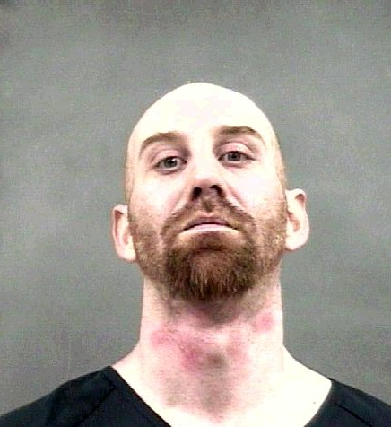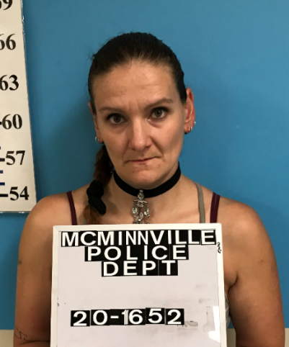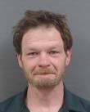
Abbott, Steven McMurray, Atheena Beutler, David
Possession of Meth Possession of Meth Theft I
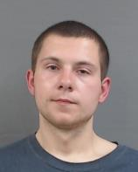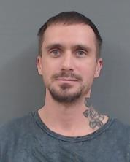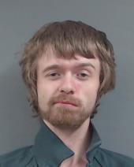
Blair, Chance Brown, Joshua Folmar, Christopher
Theft I, Possession of Meth Possession/Distribution of Meth Violation of no contact order

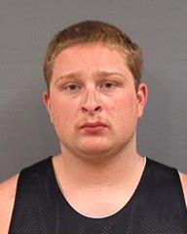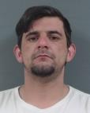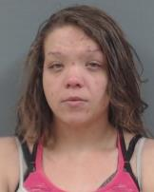
Hamill, Andrew Smith, James Ray Jones, Kendra
Possession of Meth Possession of Meth Possession of Meth

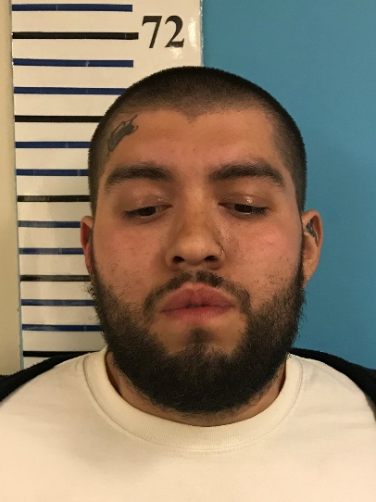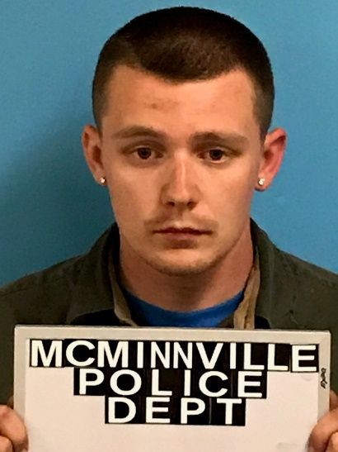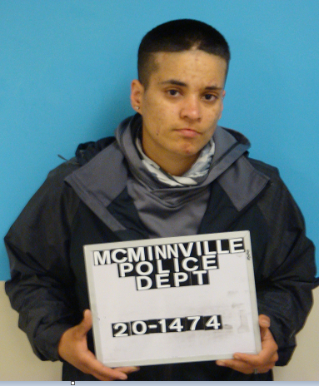
Garcia, Kelvin Richardson, Kyle Nunez, Leticia
Burlgary 2, Theft 2, Driving while suspended Theft 1, Possession of meth
Possession of burglary tools Misdemeanor
Criminal mischief 3

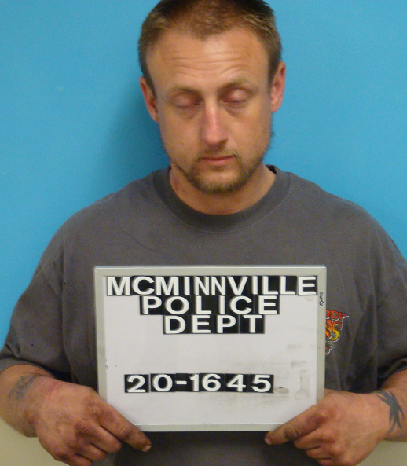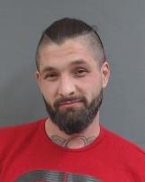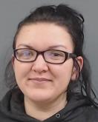
Johnson, Lucas Martin, Ramon McDowell, Ashley
Possession of meth Theft 1 Possession of Meth
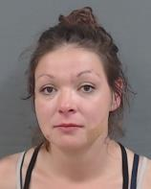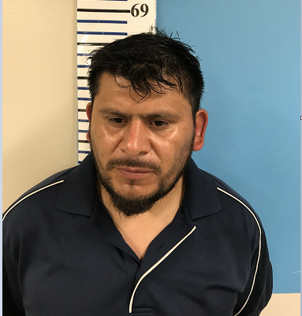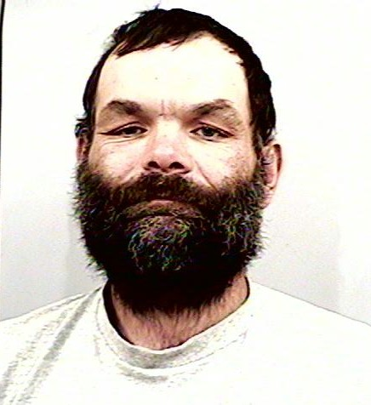
Moore, Kelsie Ayala Garcia, Ramon Spatz, Dale
Theft I / Possession of meth Burglary 2, Theft 2, Criminal Mischief 3, Theft 1
Possession of burg tools and meth

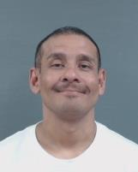
Judith Martin Willey, Natasha Robles, Luis aka Garcia, Armando
Theft 2 Distribution of Meth Criminal Mischief 3
Possession of Meth Criminal Trespass 2

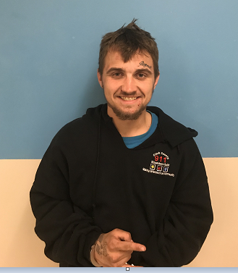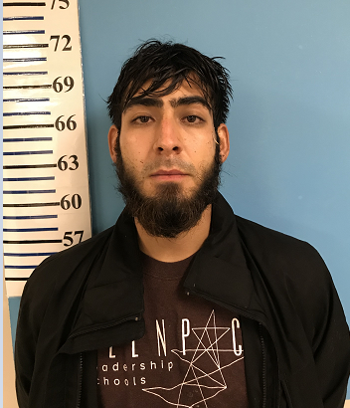
Gledhill, Raymond Barraza Lopez, Jassiel
Multiple thefts from motor vehicles Business burglaries

