**Date: January 23, 2025**

**Contact: Christine Decker, ODHS Communications: christine.l.decker@odhs.oregon.gov; 503-602-8027**

**Oregon Department of Human Services opens new Seaside offices to better serve the Clatsop County community**

**Open House is planned for Friday, January 31**

Seaside, OR – To enhance service to the Clatsop County community, the Oregon Department of Human Services opened a new building that houses Child Welfare, Oregon Eligibility Partnership Self-Sufficiency Programs. People who need these services can access them all in one place. Walk-in services and appointments are available at this ODHS office. The new building is located at 111 Roosevelt Drive.

An Open House is planned for Friday, January 31 from 10 a.m. to 2 p.m. for anyone who wants to come see the new office.

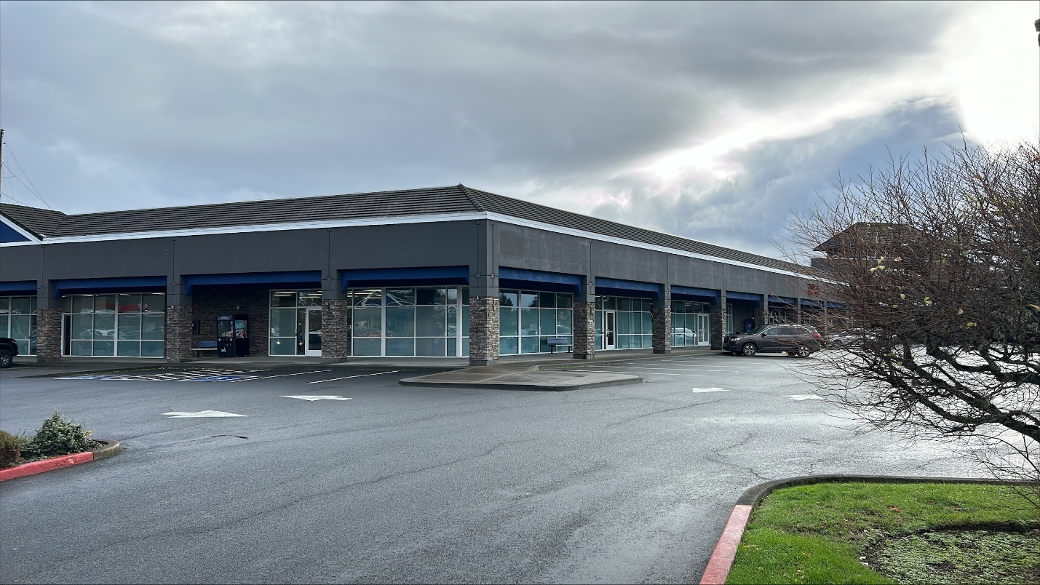 “I’m very excited about this new location! We have a real opportunity that promotes equitable access for all and having a one stop location that encompasses a variety of well-being resources and services for the people we serve,” Tim Cork, ODHS District Manager, said.

This new location, located near the Seaside Outlet Mall stores, will be a multi-service facility providing services and supports to children and families. People will be able to get support with their cash and food assistance as well as health care benefits all in one place.

Students from the Warrenton Middle and Grade schools have been invited to create art for the Child Welfare lobby. It is expected that students will be decorating a 12x14 inch wood hexagon. The hexagon shape represents the [Interdependence Hexagon Project](https://hexagonproject.org/). The Hexagon project’s mission is to spread the meaning of interdependence through school and community and to promote a sense of belonging to a broader community and common humanity. The themes typically are social justice, identity, peace and the environment expressed through art. The art is expected to be finished by April.